2520090101
04 – Joins and Set Operations
=========================================================
Question 1 - CROSS JOIN
SCENARIO:
School administration wants every student to be paired
with every available city for survey analysis.
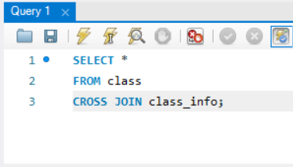
Output:
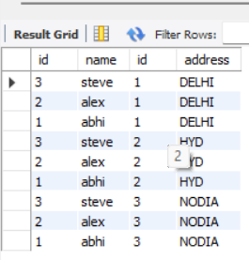
=========================================================
QUESTION 2 - INNER JOIN
SCENARIO:
Management wants only students whose address details
are available in both tables.
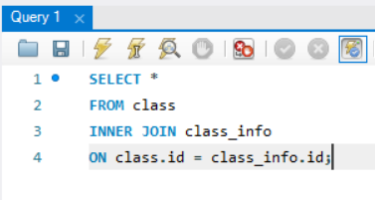

output:
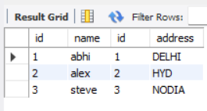
=========================================================
QUESTION 3 - INNER JOIN
SCENARIO:
Find student names and addresses for registered students.
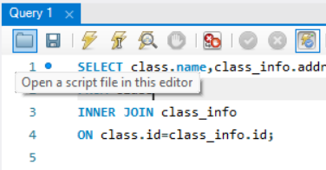
Output:
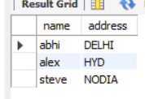
=========================================================
QUESTION 4 - NATURAL JOIN
SCENARIO:
The database administrator wants matching records
automatically joined using common columns.
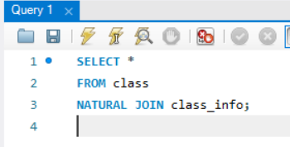

Output:
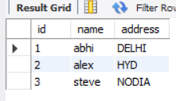
=========================================================
QUESTION 5 - LEFT JOIN
SCENARIO:
School wants all students even if address information
is not available.
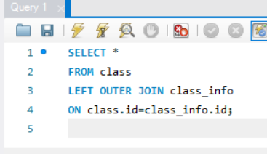
Output:
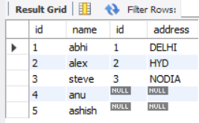
=========================================================
QUESTION 6 - LEFT JOIN
SCENARIO:
Find students who do not have address records.
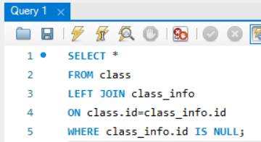
Output:
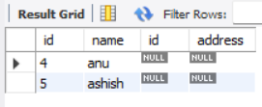
=========================================================
QUESTION 7 - RIGHT JOIN
SCENARIO:
Administration wants all address records even if
students are missing.
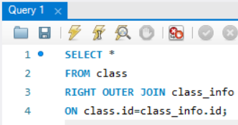
Output:
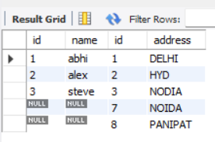
=========================================================
QUESTION 8 - RIGHT JOIN
SCENARIO:
Find address records that do not belong to any student.
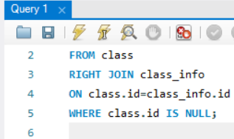

Output:
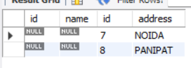
=========================================================
QUESTION 11 – UNION
SCENARIO:
Management wants a combined list without duplicates.
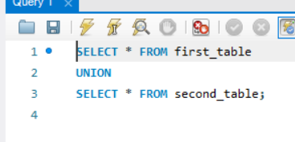
Output:
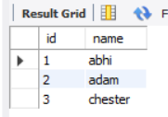
=========================================================
QUESTION 12 – UNION
SCENARIO:
Generate a master student list from two branches.
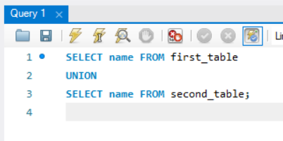
Output:
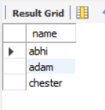
=========================================================
QUESTION 13 - UNION ALL
SCENARIO:
Management wants all records including duplicates.
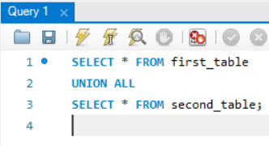
Output:
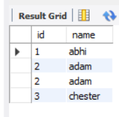
=========================================================
QUESTION 14 - UNION ALL
SCENARIO:
Count total records from both branches.
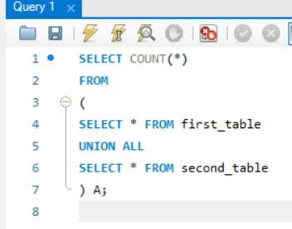
Output:
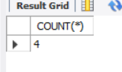
=========================================================
QUESTION 15 – INTERSECT
SCENARIO:
Find students present in both branches.
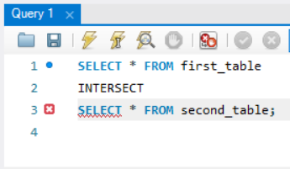
Output:
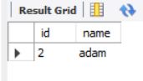
=========================================================
QUESTION 16 – INTERSECT
SCENARIO:
Find common student names.
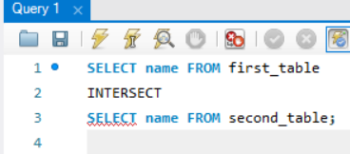
Output:
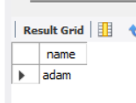=========================================================
QUESTION 19
SCENARIO:
Find students having matching addresses.
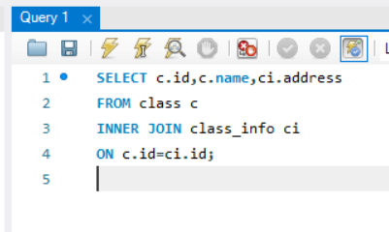
Output:
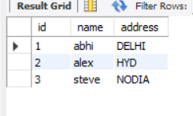=========================================================
QUESTION 20
SCENARIO:
Generate a report showing all students and address
availability status.
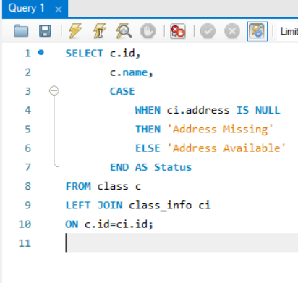
Output:
